**LAB TASK #2**

(Syeda Wajiha Hassan 24K-2509)

**Q1:** **algorithm, pseudocode & flowchart**

Algorithm –

- Display the Restaurant Menu and let the user place an order.

- Take the Customer Response (the user’s order).

- If the user inputs’ an order of 1 item.

- Ask the user if they’d like to add on more items.

- Add all items under the first process box of selecting items.

- Once the user proclaims that they don’t want to add on further.

- Print the customer’s response in form of order.

- Next, ask them to proceed with payment.

- Let them select the mode of payment.

- Print the receipt.

Pseudocode –

INPUT “Order, Payment Method”

DISPLAY “Restaurant Menu”, “Please select from the Restaurant Menu”

IF proceeds without selecting

DISPLAY “Please place the order to proceed”

IF selects 1 item

DISPLAY “Would you like to add more items on your order?”

ELSE IF proceed to payment

DISPLAY “Payment Method”

FOR Receipt = Selected Payment Method

NEXT

PRINT “Order, Receipt”

Flowchart -

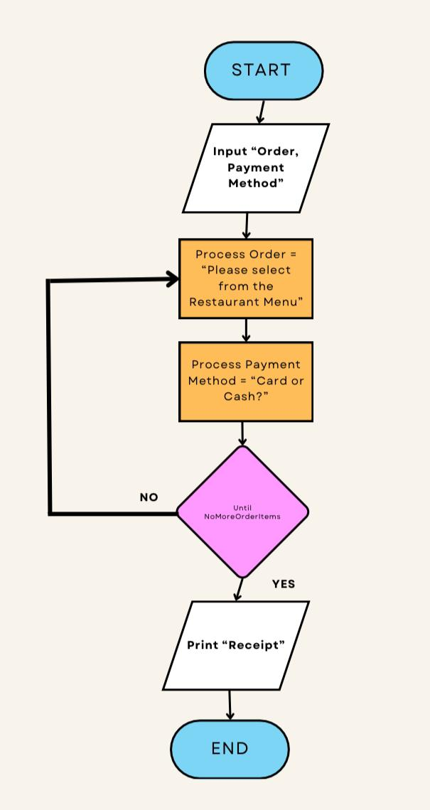

**Q2: algorithm & pseudocode**

Algorithm –

- Ask the user to enter account details.

- Check the account details.

- Check the amount present in the account.

- Upon validity ask user to deposit amount.

- Count the amount.

- Deposit the amount.

- Inform the user via SMS that amount has been deposited successfully.

- Let the system ensure with an output that deposition was done.

Pseudocode –

INPUT “Account Details, D. Amount”

IF Account Details are valid

DISPLAY “Proceed further”

ELSE IF

DISPLAY “Invalid Response”

FOR Valid Account Details = Check the Amount Present

NEXT

Sum = Amount Present and D. Amount

DISPLAY “Sum” as “Updated Balance”

IF D. Amount Deposited

THEN Inform Account Holder via SMS

PRINT “Amount Deposited Successfully”

**Q3: algorithm & pseudocode**

Algorithm –

- Take an input of 3 numbers from the user.

- Upon User’s input, check the greatest value.

- Print the number with the greatest value.

Pseudocode –

INPUT “Num1, Num2, Num3”

IF Num1 > Num2 > Num3

THEN

PRINT “Num1 is the greatest”

**Q4:** **algorithm only**

Algorithm –

- Let numbers from 1-12 be assigned for all twelve months in a chronological order.

- Ask the user to input a value from within 1-12.

- Display the corresponding month to the number.

- Upon display,

- Print the name of the corresponding month.

**Q5: pseudocode only**

Pseudocode –

INPUT “Num1, Num2”

FOR Sum = Use ‘+’

NEXT

FOR Difference = Use ‘–’

NEXT

IF User wants to Sum

DISPLAY “Num1 + Num2”

IF User wants to find Difference

DISPLAY “Num1 – Num2”

PRINT “Sum, Difference”

**Q7: algorithm**

Algorithm –

* Declare constant names for each operator.
* Let Sum = +
* Let Difference = –
* Let Product = *
* Let Divide = /
* Let Percentage = %
* After declaration, let the user to input numbers utilizing the operators.
* Upon usage of the operators between numbers, obtain the value and display it on the calculator screen as the answer.

**Q9: why we use .gitignore?**

A .gitignore file is a plain text file where each line contains a pattern for files/directories to ignore. The purpose of gitignore files is to ensure that certain files not tracked by Git remain untracked.

**Q10: difference b/w algorithm & pseudocode**

Algorithm is a set of instructions to plan a program whereas pseudocode is a draft version of a program (without the use of any programming language).

Algorithm requires specific detailed information, while pseudocode does not, it is just the least-cryptic version of the program.